Comparing Edge Detection methods

There are mainly 3 edge detection methods we are going to discuss.

1. Sobel Operator.
2. Laplacian Operator.
3. Canny Operator.

Sobel Operator

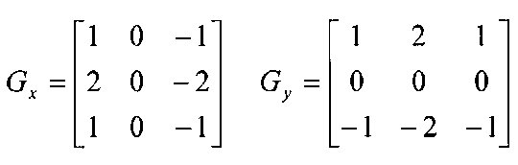The Sobel is a commonly used edge detection algorithm. It is based on convolving the image with a small separable and integer valued filter in the horizontal and the vertical direction. Therefore, it is relatively inexpensive in terms of computations. The Sobel edge enhancement filter has the advantage of providing differentiating and smoothing (removes noise) concurrently.

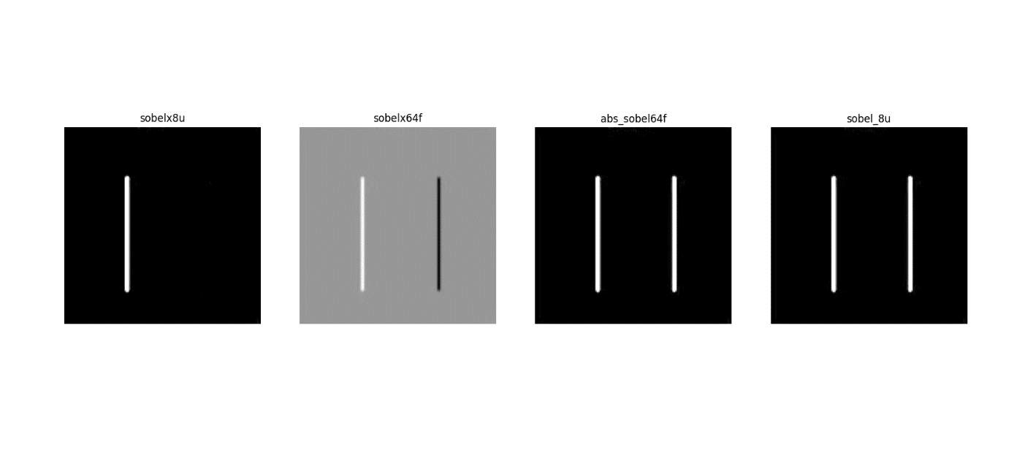Code implementing the Sobel edge detection algorithm will be attached. The results obtained from the attached implementation is shown below.

Canny Edge Detection

Canny Edge Detection is probably the most used and most effective method. The steps followed in canny edge detection is listed below.

1. Smooth the image with a Gaussian Filter to reduce noise.
2. Compute Gradient of using any of the gradient operators Sobel or Prewitt.
3. Extract edge points: Non- Maximum Suppression.
4. Linking and thresholding: Hysteresis.

Code implementing the Canny Edge detection will be attached. The results obtained from the attached implementation is shown below.

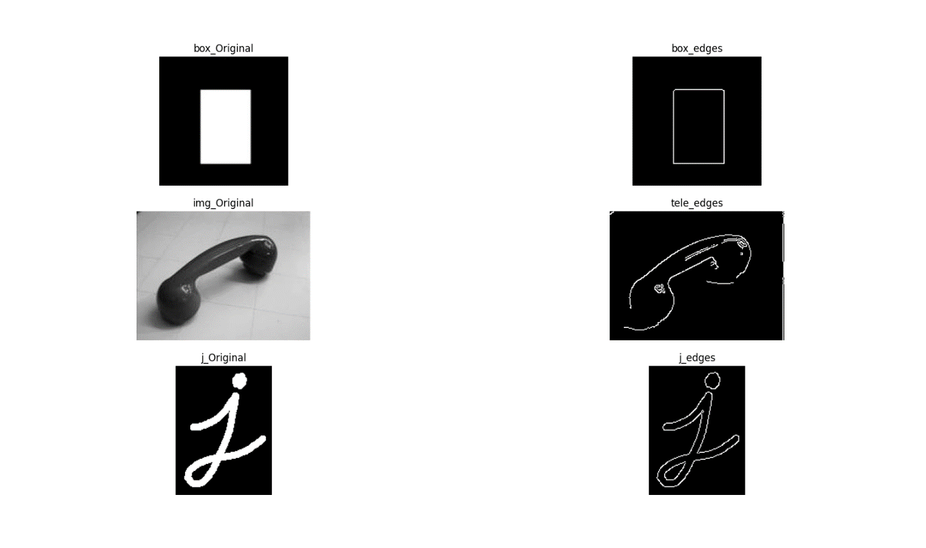

Laplacian Operator

A Laplacian filter is an edge detector which determine if a change in adjacent pixel values is from an edge or continuous progression. Laplacian is somewhat different from the method we have discussed so far. Unlike Sobel operator, the Laplacian edge detector uses only one kernel. It calculates second order derivatives in a single pass. Two commonly used small kernels are:

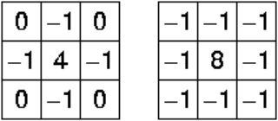

Because these masks are approximating a second derivative measurements on the image, they are very sensitive to noise. To correct this, the image is often Gaussian smoothed before applying the Laplacian filter. We can also convolve gaussian mask with the Laplacian mask and apply to the image in one pass.

Code implementing the Laplacian Edge detection will be attached. The results obtained from the attached implementation is shown below.